**Student Name:**

**Student ID:**

**Date: 20/05/2014**

ELE222E Introduction to Electronics

FINAL EXAM

*Duration: 120 Minutes*

*Grading: 1) 20%, 2) 20%, 3) 20%, 4) 20%, 5) 20%*

*Exam is in closed-notes and closed-books format; calculators are allowed*

*For your answers please use the space provided in the exam sheet*

*GOOD LUCK!*

1. Suppose that ***VB = 1,5V***and all NMOS/PMOS transistors are identical.In DC analysis, use the following equation:

.

*Transistor parameters: kp'=µpCox*=50µA/V2, *kn'=µnCox*=100µA/V2, VAn= VAp =100V, VT0,p=-1V, VT0,n=1V, WP=16µm, LP=1µm, Wn=8µm, Ln=1µm.



*Common Source Amplifier*

Determine the small signal gain ***vout/vin*** and the small signal output resistance ***rout*** of the amplifier shown above.

1. Consider an amplifier shown below*.* Suppose that the value of the coupling capacitor *CE* is high enough, so it can be considered shorted in small signal analysis.

*Transistor parameters: VBE =* 0,7V, *β = hfe =* 100*, VT =26mV, VA =∞.*

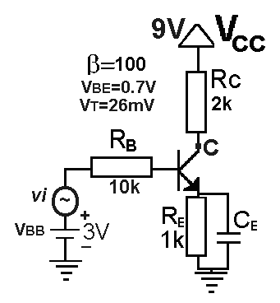

*Common Emitter Amplifier*

1. Find the DC value of the collector current ***IC***.
2. If a sine signal with 10mV peak-to-peak amplitude is applied to **vi**then determine the collector voltage **vC**’s peak-to-peak amplitude.
   * Hint: you should find the small signal gain **vC/vi** of the amplifier.
3. Consider a differential amplifier shown below*.* In DC analysis, use the following equation: .

*MOS transistor parameters: β* = 20 mA/V2, VA=∞, VTH=1V.

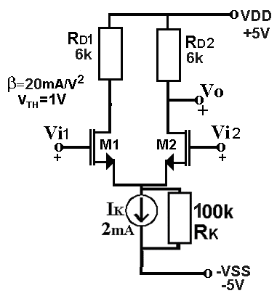 *Differential Amplifier*

1. If sine signals with 20mV and 5mV peak-to-peak amplitudes are applied to **vi1** and **vi2**, respectively then determine **vo**’s peak-to-peak amplitude.
   * Hint: you should find the small signal differential gain vo/(vi1- vi2) of the amplifier.
2. If sine signals with 10mV and 10mV peak-to-peak amplitudes are applied to **vi1** and **vi2**, respectively then determine **vo**’s peak-to-peak amplitude.
   * Hint: you should find the small signal common-mode gain Vo/Vi of the amplifier.
3. Design a BJT current source for IK. Suppose that VBE=0,6V and *β =* 200 (base current is negligible) . Neglect Early effect.
   * Hint: the current source preferably has two BJT transistors and a resistor.
4. Consider ideal OP-AMP based integrator and differentiator circuits shown below. For an ideal OP-AMP, input voltage values are **same** and input current values are both **zero**.

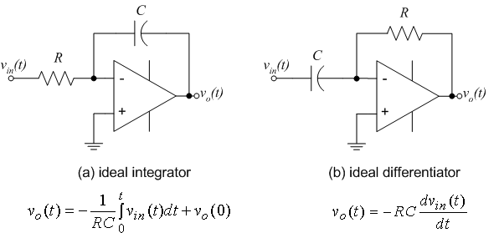

Design an ideal OP-AMP based circuit satisfying the following specification:

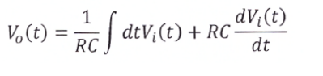

1. Consider the ideal OP-AMP based circuit shown below. For an ideal OP-AMP, input voltage values are **same** and input current values are both **zero**. Diodes have **0,7V** forward voltage values.

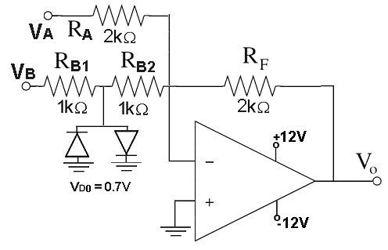 *OP-AMP Based Circuit*

For the circuit shown above, derive an expression of **Vo** in terms of the inputs **VA** and **VB**.